Diagnosis Email Instructions

Please use the following steps to create an email to share with your clients.

Step 1:
Copy and paste the subject line below into an email.
Give Your Dog More Days of Play With Librela™ (bedinvetmab injection)

Step 2:
Follow the instructions on the next page to customize your email.

Step 3:
Add the following link below the corresponding image within the email:
www.LibrelaPI.com

Step 4:
That’s it! Send the email off to your clients to help them learn about Librela.

Copy and paste Image 1

Insert your personal introduction, as well as any pet owner salutations here.

Copy and paste Image 2
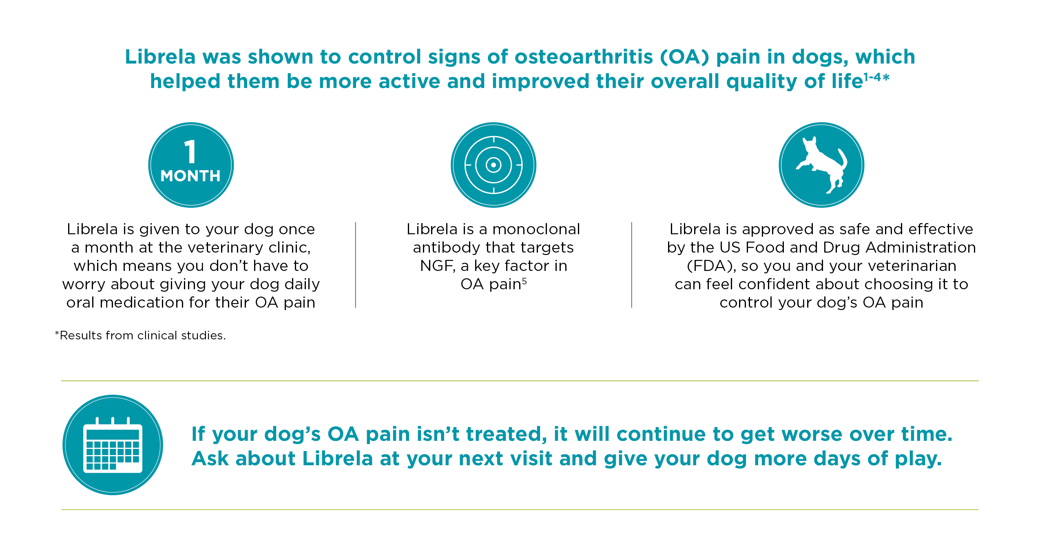

Insert your clinic’s contact information (website, phone number, etc.) along with any scheduling reminders/information. If your client has a follow-up appointment scheduled, include the date and time.

Copy and paste Image 3
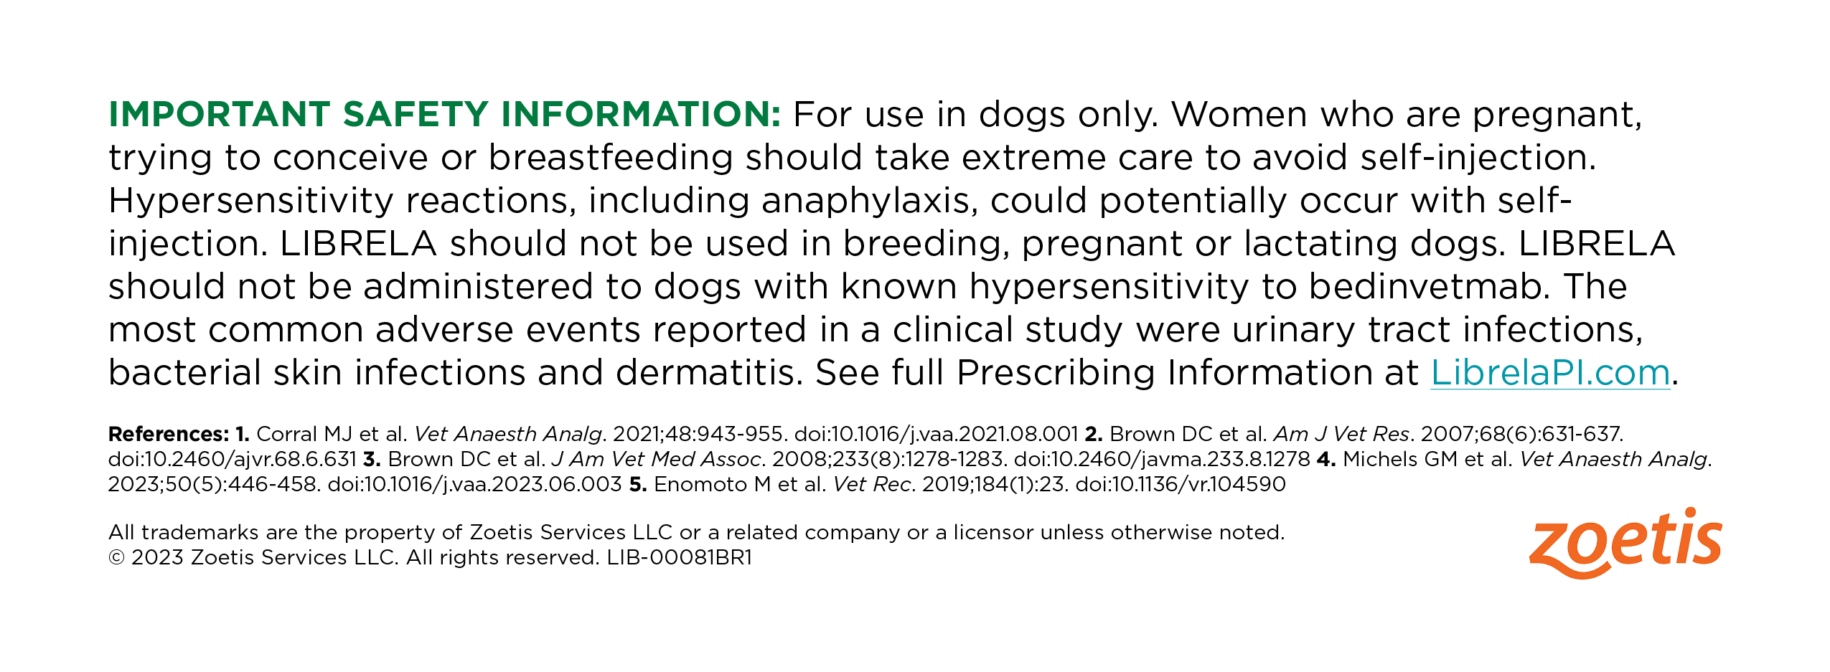

Insert www.LibrelaPI.com below Image 3.

